Module 1: Introduction to Artificial Intelligence
- What is Artificial Intelligence?

Artificial Intelligence (AI) is a branch of computer science that focuses on creating machines and software that can perform tasks typically requiring human intelligence.
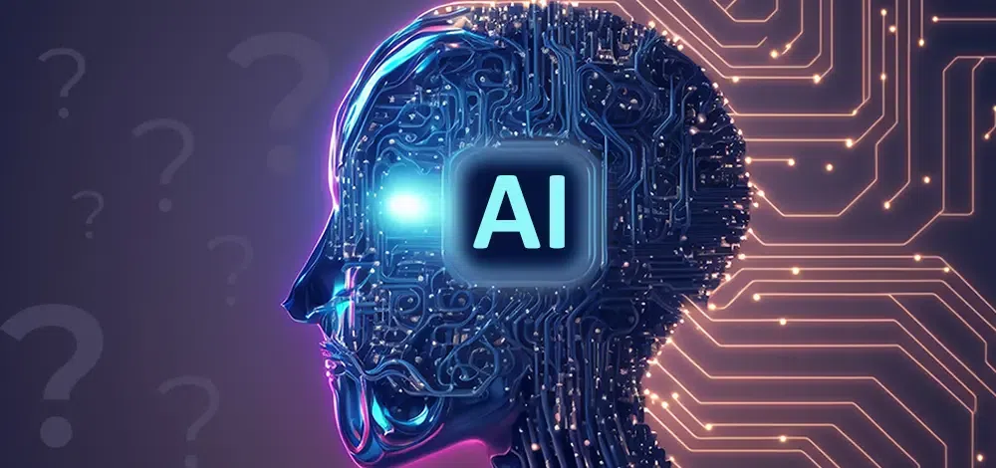

These tasks include:
- Learning (e.g., recognizing patterns, improving with experience)
- Reasoning (e.g., making decisions or solving problems)
- Understanding language (Natural Language Processing or NLP)
- Perception (e.g., recognizing speech, images, or objects)
- Interacting with the environment (e.g., robotics)

Types of AI
- Narrow AI (Weak AI)
  - Designed for a specific task (e.g., Siri, Google Maps, ChatGPT)
- Siri is an easy way to make calls, send texts, use apps, and get things done with just your voice. (virtual assistant used across iPhone, iPad, Mac etc…)
- Google Maps enhance navigation, explore the world, AI powers features like real-time traffic prediction, personalized route suggestions, and sustainable travel options.
- ChatGPT is a conversational AI chatbot developed by OpenAI. It's designed to generate human-like text, respond to prompts, and engage in conversations.
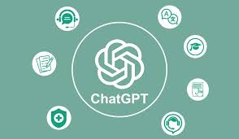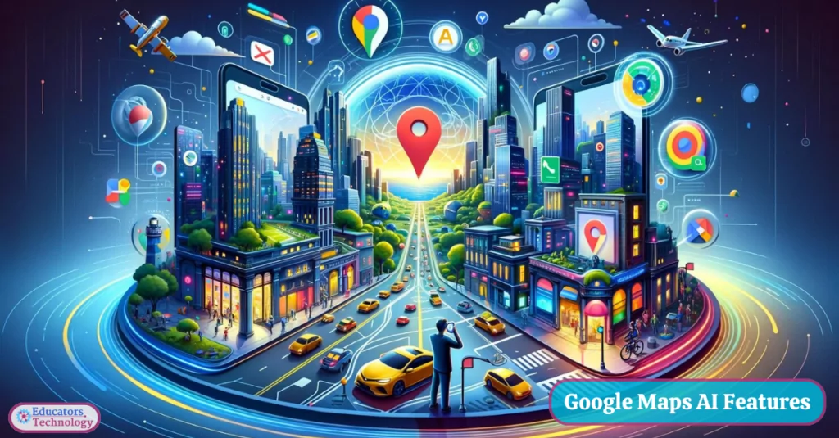

- General AI (Strong AI)
  - Has human-level intelligence across a wide range of tasks (still theoretical)
- Super AI
  - Surpasses human intelligence in all aspects (hypothetical, future concept)

Examples of AI in Use
- Voice assistants like Alexa, Siri
- Self-driving cars (e.g., Tesla)
- Chatbots for customer support
- Recommendation systems (Netflix, YouTube, Amazon)
- Fraud detection in banking

Core Technologies Behind AI
- Machine Learning (ML): AI learns from data (e.g., training a model to predict stock prices)
- Deep Learning: A type of ML using neural networks (e.g., image or speech recognition)
- Natural Language Processing (NLP): Enables machines to understand human language (e.g., ChatGPT)

- History and Evolution of AI
- 1950s – Birth of AI:
- 1956: Term "Artificial Intelligence" coined at the Dartmouth Conference.
- Early programs solved math problems and played games.
- 1970s–80s – AI Winters:
- High expectations but limited technology led to loss of funding and interest.
- 1980s – Expert Systems:
- Rule-based systems used in medicine and business, but hard to scale.
- 1990s – Machine Learning Rises
- Shift to Data-Driven AI:
  - Focus on statistical methods, neural networks, and machine learning.
- Key Milestone:
  - 1997 – IBM's Deep Blue defeated world chess champion Garry Kasparov.

- 2000s – Big Data and Smarter Algorithms
- Better Algorithms + More Data + More Power:
  - AI started being used in search engines, spam filters, recommendation systems, etc.
- Notable Use Cases:
  - Google Translate, early virtual assistants, handwriting recognition.

- 2010s – Deep Learning Revolution
- Neural Networks → Deep Learning:
  - Based on artificial neural networks with many layers.
- Breakthroughs:
  - Image recognition (e.g., AlexNet in 2012)
  - Voice assistants (Siri, Alexa, Google Assistant)
  - 2016 – AlphaGo defeated Go champion Lee Sedol
- AI Everywhere:
  - Healthcare, finance, self-driving cars, social media, etc.

- 2020s – Generative AI and Foundation Models
- Rise of Generative AI:
  - GPT models (by OpenAI), DALL·E, ChatGPT, Sora, Claude, etc.
- Applications:
  - Content creation, customer support, education, programming assistance.
- Foundation Models:
  - Trained on massive datasets; capable of multitask general intelligence.
- Ethical Concerns:
  - Bias(one side), misinformation, job displacement, and AI alignment(Designing AI systems so that their actions, decisions, and goals match human intentions and values).
Example-
Suppose a company uses AI to select job candidates.
If past hiring data mainly includes male employees, the AI may learn that men are preferred and reject qualified women candidates.
This is called AI bias.
- Applications of AI in Real Life
🔍 1. Healthcare
- Diagnosis & Treatment: AI helps in detecting diseases like cancer (e.g., skin, lung) using imaging.
- Medical Chatbots: Provide symptom checks and health advice (e.g., Ada Health).
- Robotic Surgery: AI-powered robots assist surgeons with precision.
- Drug Discovery: Speeds up new drug development (e.g., DeepMind’s AlphaFold predicts protein structure).

🚗 2. Transportation
- Self-driving Cars: Tesla, Waymo, and others use AI for autonomous vehicles.
- Traffic Management: AI controls signals and predicts traffic patterns.
- Fleet Management: Optimizing routes, fuel usage, and maintenance using AI (e.g., Uber, Ola).

🛒 3. Retail & E-commerce
- Product Recommendations: AI recommends items based on user behavior (Amazon, Flipkart).
- Chatbots & Virtual Assistants: 24/7 customer service (e.g., Meesho’s AI assistant).
- Inventory Management: Predicts demand and manages stock automatically.

📱 4. Smartphones & Gadgets
- Voice Assistants: Siri, Alexa, Google Assistant use AI for speech recognition and natural language processing.
- Face Recognition: Used for phone unlocking and security.
- Camera Enhancements: AI improves image quality and adds effects in real time.

📷 5. Social Media
- Content Curation: AI recommends posts, reels, and ads (e.g., Instagram, YouTube).
- Moderation: Detects and removes inappropriate content or spam.
- Deepfake Detection: AI helps detect manipulated media.

💼 6. Business & Finance
- Fraud Detection: AI detects unusual banking transactions.
- Credit Scoring: Loan eligibility is assessed using AI algorithms.
- Algorithmic Trading: AI buys and sells stocks at optimal prices.

🏠 7. Smart Homes
- Home Assistants: AI controls lights, AC, appliances (e.g., Google Nest, Alexa).
- Energy Efficiency: AI learns habits and adjusts settings to save electricity.
- Security Systems: AI-enabled CCTV detects motion or intrusions.

📚 8. Education
- Personalized Learning: Platforms like BYJU’S and Khan Academy adapt content using AI.
- Automated Grading: AI checks assignments and MCQs.
- Language Translation: Real-time translation in apps like Google Translate.

🎮 9. Entertainment & Gaming
- Game AI: NPC behavior and strategy adapts to player style.
- Content Creation: AI writes scripts, music, or even edits videos.
- Streaming Recommendations: Netflix, Spotify suggest what to watch/listen next.

🏭 10. Manufacturing
- Predictive Maintenance: AI predicts when machines need repair.
- Robotics & Automation: AI-driven robots handle repetitive tasks.
- Quality Control: Detects defects in products using computer vision.

- AI vs. Machine Learning vs. Deep Learning

🔹 1. Artificial Intelligence (AI)
- Definition: A broad field of computer science focused on creating machines that can simulate human intelligence.
- Goal: Enable machines to think, reason, learn, and make decisions.
- Examples:
  - Chatbots (like ChatGPT)
  - Self-driving cars
  - Face recognition
  - Smart assistants (Alexa, Siri)

🔹 2. Machine Learning (ML)
- Definition: A subset of AI where machines are trained on data to learn and improve over time without being explicitly programmed.
- Goal: Let machines learn patterns from data and make predictions or decisions.
- Examples:
  - Spam email detection
  - Product recommendation (Amazon, Netflix)
  - Stock price prediction

🔹 3. Deep Learning (DL)
- Definition: A subset of ML that uses neural networks with many layers (hence "deep") to analyze complex patterns.
- Goal: Handle complex problems like image recognition, speech translation, etc.
- Examples:
  - Face recognition on Facebook
  - Voice assistants understanding language
  - Autonomous driving systems

🔄 Relationship Diagram

Artificial Intelligence
│
├── Machine Learning
│ └── Deep Learning

- Ethics and Challenges in AI

Ethics in AI
Ethics in AI deals with ensuring that AI systems are fair, safe, transparent, and accountable. Key areas include:
- Bias and Fairness
  - AI systems can inherit biases from training data.
  - Leads to discrimination in hiring, lending, policing, healthcare, etc.
  - Ethical concern: "Who gets unfairly advantaged or disadvantaged?"
- Transparency and Explainability
  - Many AI models (like deep learning) work as "black boxes."
  - Users and regulators demand that AI decisions be explainable.
  - Ethical concern: "Can humans understand and trust AI’s decisions?"
- Privacy
  - AI often requires massive amounts of personal data.
  - Raises questions about surveillance, consent, and data misuse.
  - Example: Facial recognition in public spaces.
- Autonomy and Accountability
  - Who is responsible when AI makes a wrong or harmful decision?
  - Example: Self-driving cars causing accidents.
  - Need clear accountability frameworks.
- Employment and Economic Disruption
  - AI automation threatens traditional jobs.
  - Ethical dilemma: "How do we balance efficiency with human livelihood?"
- Security and Misuse
  - AI can be weaponized (e.g., deepfakes, autonomous weapons, cyberattacks).
  - Ethical concern: "How do we prevent harmful applications?"

Challenges in AI
Building ethical and reliable AI involves several practical challenges:
- Data Quality and Availability
  - AI depends on large, clean datasets.
  - Challenge: Obtaining unbiased, representative, and diverse data.
- Interpretability
  - Deep neural networks are difficult to interpret.
  - Challenge: Making AI explainable without losing performance.
- Scalability and Efficiency
  - Training advanced AI requires huge computational power.
  - Challenge: Environmental impact (energy consumption, carbon footprint).
- Regulation and Governance
  - Global AI regulation is still evolving.
  - Challenge: Balancing innovation with safety and ethics.
- Human-AI Collaboration
  - Ensuring AI complements human intelligence rather than replacing it.
  - Challenge: Building trust in AI-human teamwork.
- Security Risks
  - Adversarial attacks can trick AI systems.
  - Challenge: Making AI robust and secure against manipulation.

AI website for different work
1.https://songgenerator.io/app (for song creation from text)
2.Eleven Lab(voice generation)
3.Lyrebird(Voice generation)
4.Runway(for video creation)
5.Sora(for video creation)
6.openart.ai(image creation)
7.app.aistudios.com(text-to-video)
8.https://www.craiyon.com/ (for image generation free)
9.https://deepai.org/ (for image/video generation)
10. https://stablediffusionweb.com/app/image-generator (Text to image)

